**Heart Beat Rate Monitoring System**

**Sudhansu Kumar Maharana, Satyaki Chakraborti, Madhab Jyoti Mohanty and Sonu Kumar**

**Guided by: Prof. Pravin Kumar Samanta**

**Abstract-** During this age of innovation and technology, people's life is getting easier as new gadgets and devices are coming out with the capability complementing their work lives. There are gadgets that can monitor their health parameters constantly irrespective of time or location. Though the biggest setback would be the price. Majority of deaths in the world happens due to cardiovascular diseases (CVD). As soon one can know their health parameters the better. With the increase in population and workload, people ignore their health most of the time because of constraints on time and place. One of the examples of CVD would be Atrial Fibrillation (a form of Arrhythmia) where the tempo or the time between each heartbeat will vary. The demand for easy and affordable health care is increasing rapidly and especially in remote locations. In this era, the cost of basic health monitoring devices have decreased and the communication gap between the doctors or medical personnel and patients is also decreasing. So, in this report, the capability of fast and easy access through web page and Python are implemented together as optimization techniques to reduce error and make things platform-independent to monitor the patient in real-time.

**Keywords-** Heart, Heartbeat, Cardiovascular diseases (CVD), Python, Flask, HTML, CSS, Light Intensity

1. **Introduction**

From smallest beings like ants to the largest beings like whales, heart is the most important organ, it has the responsibility for pumping blood through the blood vessels of the circulatory system. Oxygen and nutrients that are used for metabolic waste removal which is a very vital process for our survival which is carried out using blood. The average heartbeat of a healthy person is close to 72 heart beats per minute at resting state. The beats per minute can go down to 30 – 40 beats per minute for well-trained athletes. So the heart rate increases while exercising and if a person stays persistent in this their heart beat decreases at resting state which is a very healthy sign. Now as for how the heartbeat rhythm while pumping of the blood came to be, it is because of the pace making cells present in the sinoatrial node. Everyone should always keep their health factors in check, regardless of their age, gender, habits or work environment. Most of the medical equipment required for monitoring heart beat rate that are available to the public for low prices are inaccurate when the heart beat rate goes above a certain frequency or the ones that are highly accurate happen to be very expensive. So our system takes into account for the above mentioned factors and disadvantages to give a better and economical result.

1. **Proposed Model**

The main model is made using Python and the GUI us made using HTML and CSS. Both are then connected using Flask. The system take a video input of the finger tip on top a small light source in a dark environment just like the Oximeter. The video is taken in and processed using OpenCV. The video is converted to greyscale and light intensity values of each frame are taken in and plotted.

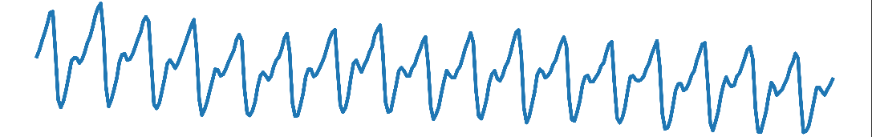

Figure 1 Plot 1, unfiltered, unrectified

After getting the basic data and plot, the data is then filtered and is straightened out with respect to the y-axis.

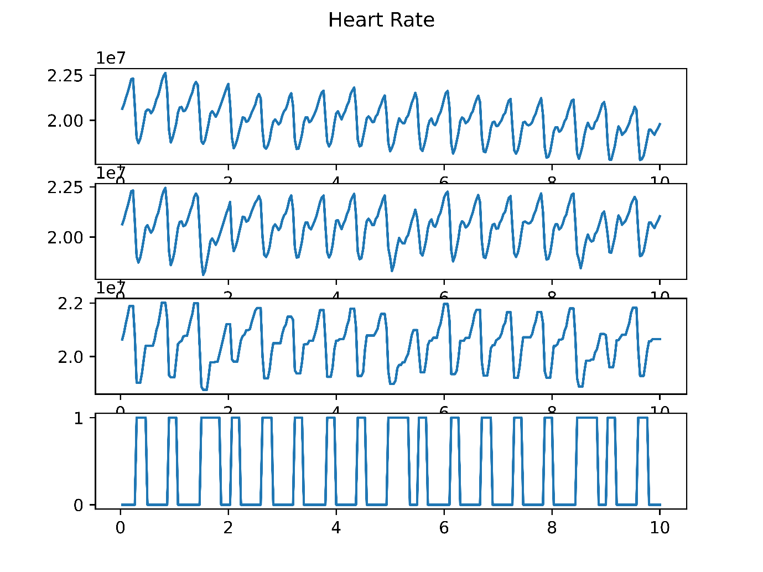

Figure 2 Plot filtered but unrectified

Now the final part is to rectify the graph. The data which represents Figure 2 is converted to a square wave as shown in Figure 3.



Figure 3 Filtered and Rectified

From Figure 3 the number of pulses are counted, in this case it is 17 pulses and the video that was taken as input is of the length of 10 seconds. So heart beat rate per minute is 17 × 6 = 102.

*******Final Webpage Output here********

*******Results Table********

This tabulation indicates the patient’s heart rate after any vigorous /normal activity done by the patient and resting heart rate. From the tabulation, we get a perspective of the varying heart rate for both morning and evening hours with the state of the patient during the measurement of heart rate. Different conditions state different details of the person’s state when he took the fingertip video. Resting conditions states that the person was on resting condition and have not moved from his place for at least past 10 mins. Moderate activity states that the person has been doing some mild activity which includes walking or standing. Strenuous activity states that the person was doing some rigorous work which may include jogging, running etc. The average heartrate of a person ranges from 60 to 100 bpm for a normal healthy person. So the above data shows that the person is normal and will lead a healthy life.

|  |  |  |  |  |  |  |  |  |
| --- | --- | --- | --- | --- | --- | --- | --- | --- |
| **Days** | **Morning** | | | | **Evening** | | | |
| **Heartbeat Rate** | **Machine HRM** | **Condition** | **Error** | **Heartbeat Rate** | **Machine HRM** | **Condition** | **Error** |
| Day – 1 | 78 | 74 | Resting | -4 | 84 | 89 | Moderate Activity | +5 |
| Day – 2 | 78 | 73 | Resting | -5 | 90 | 88 | Moderate Activity | -2 |
| Day – 3 | 84 | 88 | Moderate Activity | +4 | 102 | 99 | After strenuous activity | -3 |
| Day – 4 | 72 | 74 | Resting | +2 | 84 | 85 | Moderate Activity | +1 |
| Day – 5 | 78 | 81 | Resting | +3 | 96 | 93 | After strenuous activity | -3 |

1. **Conclusion**

Nowadays taking care of health must be of utmost importance especially as we neglect ourselves of following healthy life majorly due to the hectic life we all are going and surviving through to make both ends meet. But maintaining this simple yet important aspect is an arduous task. Having to go to the doctors now and then could be tedious but also in the contrary could reduce the risk of critical cases. Another difficulty could be for the people living in the rural areas as the medical establishment could be far away. But as technology is developing, almost everything can be done from home. This system thus is capable of generating medical report without any intervention of doctors and also patients get an added advantage of having the option to have a personal medical feedback from an experienced doctor. If any abnormalities are found beforehand critical situations could be avoided. Our purposed model intends to reduce the cost of monitoring patients regardless of location.